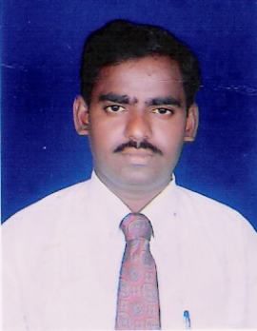
CURRICULUM VITAE

Vangapati Venkataiah
S/O Venkatakrishnaiah
Door No.15/794, B.P.Agraharam
Srikalahasti town, Chittoor District
Andhra Pradesh – 517 640
INDIA

Career Objective:

To work in challenging environment and to have a grate responsibility, where I could exhibit my knowledge and skills for the betterment for an organization and self.

Academic Details:-

- B.A., (History, Economics, Political Science) 1992-95
Sri Venkateswara university, Tirupati- 517 502

- B. L., (Academic laws) 1996 -1999
Sri Venkateswara University, Tirupati- 517 502

Important subjects studied in B.L.,

- Law of Contracts
- Criminal law
- Law of Torts
- Family and the Law
- Administrative Law
- International Law
- Environmental Law
- Law and Property Relations
- Law and Rural Development
- Law, Science and Technology
- Consumer Justice
- Indian Constitutional Law
- Jurisprudence
- Elements of Indian Legal System

Working Experience:-

1. Working as a Trainee Advocate under the Andhra Pradesh State Government, India vide G.O.Rt No.506 dated 24.03.2005, vide collectors office – Chittoor in ROC NO.C5/2981/2003 dated 09.04.2005 undergoing training by attaching to the Assistant Public Prosecutor, Additional Judicial first class Magistrate court, Srikalahasti town, Chittoor District, Andhra Pradesh State, India.

2. Practicing at Srikalahasti, Tirupati, Vijayawada, Venkatagiri courts from 06.07.2000 both Criminal and civil side having nearly 7 years experience.

- Dealing nearly 300 cases both in civil and Criminal
Side. Completed cases nearly 400

Additional Qualifications:

- N.C.C. ‘C’ Certificate Holder (Army)
APS/C/Cert/Army/95/0877

- N.C.C. ‘B’ Certificate Holder ( Army)
APS/B/Cert/Army/ 94/0232

- Type writer English Higher (45 words per minute)

- Good touch with computer M.S.word, M.S.Office,
M.S.Excel

- Organizer for Bhagavan Seva Samithi,(Social Services)
- Swarmanukhi Chaithnya Sangham (Social Services)

Documentation Experience:

- Preparation of cases in computer
- Preparation of Arguments

PERSONAL PROFILE

Full Name (In Block Letters) : VANGAPATI VENKATAIAH

Fathers Name : VENKATAKRISHNAIAH

Date of Birth : 08.05.1975 (32 years)

Sex : Male

Marital Status : Married

Nationality : Indian - Hindu

Languages known : Telugu, English,Hindi, Tamil

Permanent Address : Vangapati Venkataiah
S/O Venkatakrishnaiah
Door No.15/794, B.P.Agraharam
Srikalahasti town, Chittoor District
Andhra Pradesh – 517 640
INDIA

DECLARATION

I, hereby declare that the above information given by me is true to the best of my knowledge and belief.

Yours faithfully,
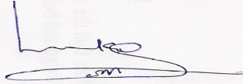
Place: Srikalahasti,
Date: 06.03.2007

(Vangapati Venkataiah)

In view of the above, I request you to kind enough to give me an opportunity to serve your esteemed organization kin the capacity mentioned above, for which act of kindness I shall be very grateful to you.

Thanking you sir,

Yours faithfully,
Place:
Date:

